Prospective life cycle analysis of green platform chemicals uncovers their full environmental potential
Abhinandan Nabera,ª Ioan-Robert Istrate,^{b} Antonio José Martín,ª Javier Pérez-Ramírez,^{a,}* Gonzalo Guillén-Gosálbez^{a,}*
ªDepartment of Chemistry and Applied Biosciences, ETH Zurich, 8093 Zurich, Switzerland
^{b}Institute of Environmental Sciences (CML), Leiden University, 2333 CC Leiden, The Netherlands
*jpr@chem.ethz.ch, gonzalo.guillen.gosalbez@chem.ethz.ch
Abstract
Current life cycle assessments (LCAs) of conventional and emerging chemical technologies often neglect future changes in the economy required to meet climate goals, such as those affecting transportation systems and heat and power generation. Disregarding these trends, which will shape the future economy, could lead to less accurate assessments and spurious conclusions. Hence, in this study, we conduct a prospective life cycle assessment (LCA) to understand how future changes in the economy (until 2050) will affect the environmental impact of chemicals, using ammonia as a representative case. To achieve this, we use background data consistent with climate policies aimed at limiting global temperature rise across 26 regions. Our findings reveal that the environmental gap between fossil and green ammonia will significantly increase in the future, with solar-based routes showing the most improvement due to efficiency gains in solar panels and their lower carbon footprint resulting from the decarbonization of the energy mixes used in their manufacture. Overall, this study emphasizes the importance of considering future trends in the assessment of chemical technologies to draw a more comprehensive picture of their environmental potential.
Keywords: climate policies, platform chemicals, prospective life cycle assessment.
  - Introduction
The chemical industry poses a formidable challenge towards decarbonization, primarily due to its heavy reliance on fossil fuels, leading to 5.6 Gt CO₂-eq, accounting for 10% of global GHG emissions (Bauer et al., 2023). Moreover, only one-third of these emissions are direct, with the remaining attributed to energy acquisition and the upstream value chain, highlighting the industry’s dependence on global energy systems and supply chains. However, this challenge also presents an opportunity to reduce environmental impacts in chemical production through decarbonization of other key sectors. In recent times there have been rapid technological advancements in response to decarbonization challenges and climate policies aligned with the Paris Agreement. In this context, key platform chemicals such as ammonia could play a crucial role in reducing emissions due to their large production volumes and diverse applications. Several studies have evaluated low-carbon production routes for both ammonia and methanol from renewable carbon and hydrogen-based feedstocks (D’Angelo et al., 2021; Gomez et al., 2020). These analyses have consistently highlighted the environmental superiority of green routes over their fossil counterparts. However, the majority of them often assume that the foreground system (chemical plant) interacts with the existing energy systems and supply chains, neglecting forthcoming decarbonization efforts, which could lead to less accurate and meaningful assessments. Hence, in this work, we evaluate the environmental impacts of fossil and green ammonia pathways until 2050, by considering expected changes in the power, materials, and transportation sectors under three climate scenarios: a baseline scenario (3.5 °C), and two scenarios consistent with the 2 °C and 1.5 °C targets, respectively. Furthermore, we highlight the significance of locations in decision-making, by performing a temporal region-specific prospective LCA for 26 regions. Our results show that green ammonia could become in the future more environmentally appealing than originally thought.
  - Methods
We employ the IMAGE Integrated Assessment Model (IAM) to evaluate the environmental performance of both fossil and green pathways for ammonia production. This enables us to project potential economic scenarios and provides insights into the environmental impacts based on expected socioeconomic and technological advancements. Specifically, we adopt the middle-of-the-road shared socioeconomic pathway (SSP2) and consider a range of representative concentration pathways (RCPs), including RCP6, RCP2.6, and RCP1.9. RCP6 corresponds to a scenario limiting global temperature rise to 3.5 °C, while RCP2.6 and RCP1.9 correspond to scenarios limiting temperature rise to 2 °C and 1.5 °C, respectively. To generate inventories for prospective LCAs covering the time period from 2020 to 2050, we utilize the premise v1.5.9 framework (Sacchi et al., 2022). Additionally, we perform a regional assessment for the production of these platform chemicals across 26 global regions, considering location-specific temporal dynamics.
  - Results and Discussions
The impact of both fossil and green ammonia will decline in the future, but the environmental gap between them will grow substantially, thus drastically improving the environmental appeal of green ammonia (Figure 1a). Particularly, under an aggressive climate policy, such as the 1.5 °C scenario, these impacts will decrease significantly, with both the solar and wind-based pathways reducing their impact by 70% in 2050 (compared to 4% in the fossil analogue). Furthermore, a regional assessment reveals that impact reductions vary significantly by region for both solar (Figure 1b) and wind-based (Figure 1c) ammonia, highlighting the crucial role of maximizing the location of green facilities to maximize global benefits.
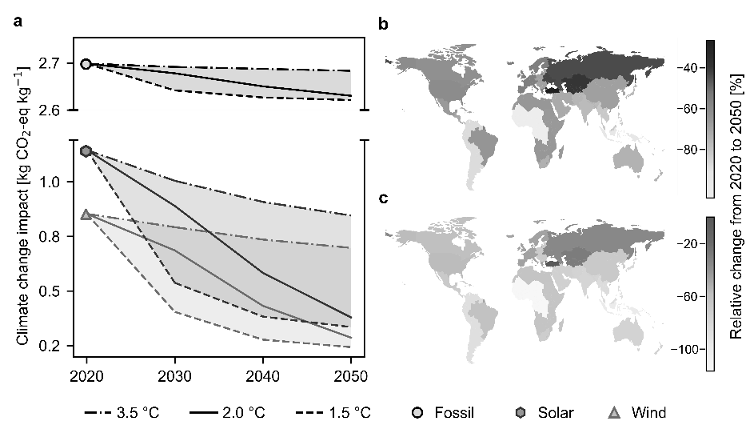
Figure 1 Climate change impacts of ammonia production technologies. (a) Global average impacts of fossil, solar and wind-based production from 2020 to 2050 across three scenarios (3.5 °C, 2 °C, and 1.5 °C). Regional analysis under the 2 °C scenario for (b) solar and (c) wind-based production pathways.
  - Conclusions
In this work, we assess the impact of future economic trends, focusing on climate policies, on key platform chemicals, taking ammonia as a testbed and performing an analysis across 26 regions spanning from 2020 to 2050. We found that while the impact of the fossil and green routes will both decline, the gap between the two will grow, and more so under ambitious climate policies. We also highlight the role of the facilities’ location in the analysis, which can greatly affect the results over time. Overall, this work underscores the importance of considering technological advancements, market trends, and regional considerations in the LCA of emerging chemical technologies. We hope this study will help in making better decisions in the transition towards more sustainable chemicals.
References
Bauer, F., Tilsted, J.P., Pfister, S., Oberschelp, C., Kulionis, V., 2023. Mapping GHG emissions and prospects for renewable energy in the chemical industry. Curr. Opin. Chem. Eng. 39, 100881.
D’Angelo, S.C., Cobo, S., Tulus, V., Nabera, A., Martín, A.J., Pérez-Ramírez, J., Guillén-Gosálbez, G., 2021. Planetary Boundaries Analysis of Low-Carbon Ammonia Production Routes. ACS Sustain. Chem. Eng. 9, 9740–9749.
Gomez, J.R., Baca, J., Garzon, F., 2020. Techno-economic analysis and life cycle assessment for electrochemical ammonia production using proton conducting membrane. Int. J. Hydrog. Energy 45, 721–737.
Sacchi, R., Terlouw, T., Siala, K., Dirnaichner, A., Bauer, C., Cox, B., Mutel, C., Daioglou, V., Luderer, G., 2022. PRospective EnvironMental Impact asSEment (premise): A streamlined approach to producing databases for prospective life cycle assessment using integrated assessment models. Renew. Sustain. Energy Rev. 160, 112311.

